Project Proposal: Room Occupancy Detection Using Environmental Sensor Data
Introduction
This project looks at room occupancy detection as an Internet of Things problem. It uses sensor data to predict whether a room is occupied or not. This matters in smart buildings because it can help control lights, heating, cooling, and ventilation more efficiently. That can save energy, improve comfort, and make building systems work better. The UCI Occupancy Detection dataset is a good choice because it is a simple binary classification problem with 20,560 data points, 6 features, and no missing values. The labels were made using time stamped pictures taken every minute, so it is a clear and practical supervised learning task.
This is also a good IoT topic because the data comes from sensors often used in smart buildings, such as temperature, humidity, light, CO₂, and humidity ratio. These sensors are better for privacy than cameras, which makes them useful in places like schools, offices, and homes. Research also shows that this kind of sensing can help with energy saving, safety, and automation, especially when a less invasive method is needed.
Researchers have already studied this problem using statistics and machine learning methods. The original paper for the UCI dataset was written by Candanedo and Feldheim and looked at occupancy detection using light, temperature, humidity, and CO₂ data. Newer studies have also tested many models on this same dataset, such as Logistic Regression, SVM, Decision Trees, Random Forest, and ensemble methods. This makes it a good project for a class because there is already related research, the dataset is clean, and there is enough background information for both the proposal and the final report.
Possible Approaches
For this project, I will compare two algorithms: Logistic Regression and Random Forest. I chose Logistic Regression because it is simple, fast, and easy to understand, so it works well as a basic starting model. I chose Random Forest because it can handle more complex patterns in the sensor data. By comparing them, I can see whether a simple model is enough or if a more advanced model works better. These two methods are also common choices in occupancy detection and similar classification problems.
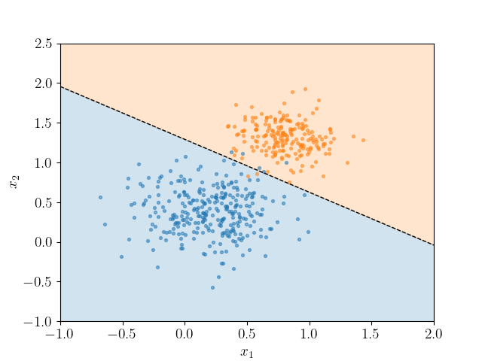
Example of Logistic Regression used for binary classification. The line shows how the model separates occupied and not occupied classes based on sensor data.

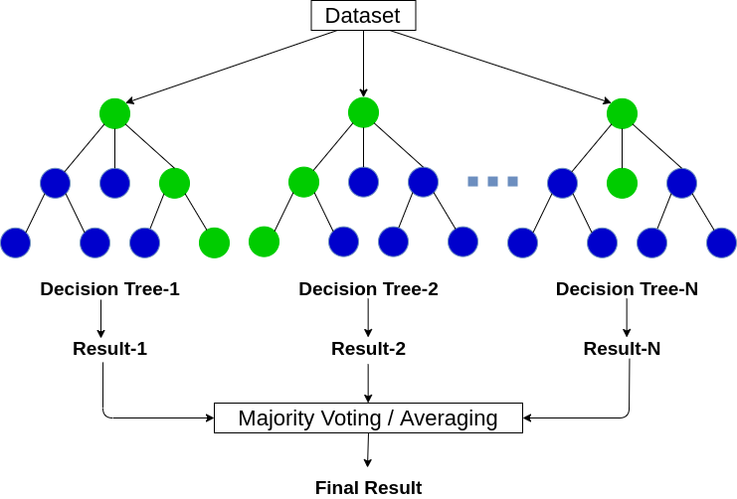
Random Forest classification model. Multiple decision trees are built from the dataset, and their results are combined through majority voting to produce the final prediction.

The experiments are simple. First, I will clean the dataset and split it into training and testing data. Then I will train Logistic Regression and Random Forest using the same features. After that, I will compare their results using accuracy, precision, recall, F1 score, and a confusion matrix. I also want to check if scaling the features helps, especially for Logistic Regression. For Random Forest, I will also look at which sensor features seem most important. These experiments match what other studies have done, but they are still small enough for a class project.
Research Plan
My research plan is spread over a few weeks, but I want to do most of the work during the weekend of April 3, 2026, and finish the project by April 14, 2026. During that weekend, I plan to read the main papers, download and clean the dataset, explore the data, and build both models. By April 14, 2026, I want to have the models tested, the results compared, and the main writing mostly finished. After that, I can just make small edits, add the algorithm pictures, and organize the final references.
References
Candanedo, L. M., and V. Feldheim. Accurate occupancy detection of an office room from light, temperature, humidity and CO₂ measurements using statistical learning models. Energy and Buildings, 112, 2016. Listed as the introductory paper for the UCI Occupancy Detection dataset.
UCI Machine Learning Repository. Occupancy Detection dataset. 20,560 instances, 6 features, binary occupancy target, no missing values.
Zhang, W. et al. A review on occupancy prediction through machine learning for enhancing energy efficiency, air quality and thermal comfort in the built environment. Renewable and Sustainable Energy Reviews, 2022.
Logistic Regression in Machine Learning.” GeeksforGeeks, 23 Dec. 2025.
Random Forest Algorithm in Machine Learning.” GeeksforGeeks, 23 Dec. 2025.

